Task 1: Main Internal Components of a Desktop PC
- Motherboard: The main circuit board that connects all hardware components together and lets them communicate.
- Central Processing Unit (CPU): The primary processor (the "brain") that executes program instructions and calculations.
- CPU Cooler / Heatsink: A metal fin assembly with a fan (or liquid system) that draws heat away from the processor.
- RAM (Random Access Memory): Fast temporary memory used to hold data for running programs.
- Storage Drive (SSD / HDD): Permanent storage that holds the operating system, personal files, and installed software.
- Power Supply Unit (PSU): Converts high-voltage wall electricity into safe, low-voltage DC power for all internal parts.
- Graphics Card (Dedicated GPU): A specialized expansion card that processes and outputs images, 3D graphics, and video to the monitor.
- Case Fans: Fans attached to the chassis walls that push cool air in and exhaust hot air out.

Task 2: Step-by-Step PC Disassembly Guide

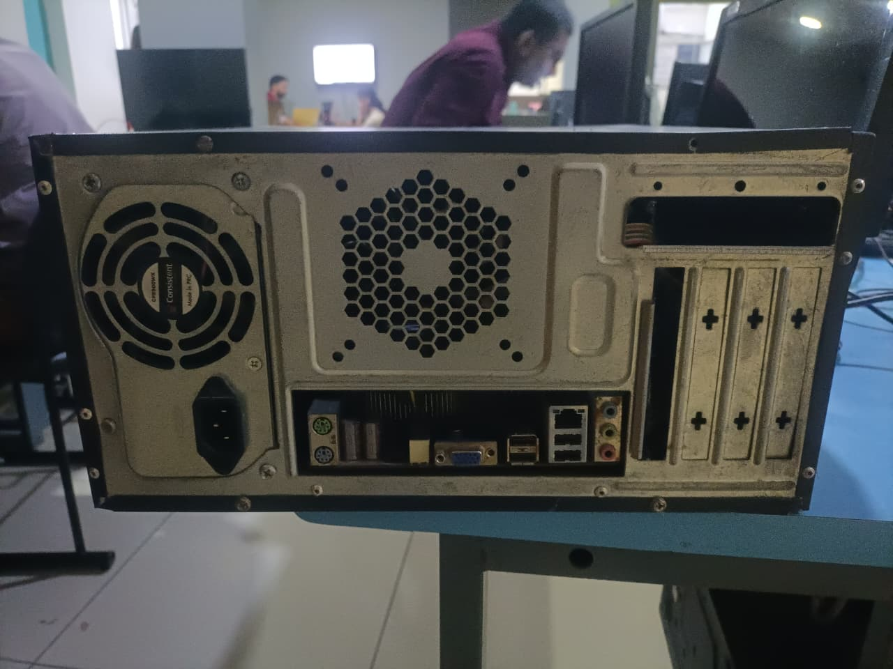
- Step 1: Power Down & Unplug External Cables: Turn off the PC, flip the cabinet and unplug the power cord, display cables, and USB accessories.

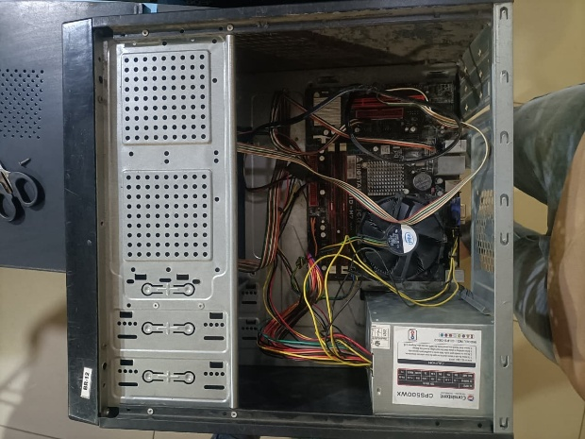
- Step 2: Remove the Side Panels: Unscrew the rear thumbscrews and slide off both side panels to access the chassis interior.

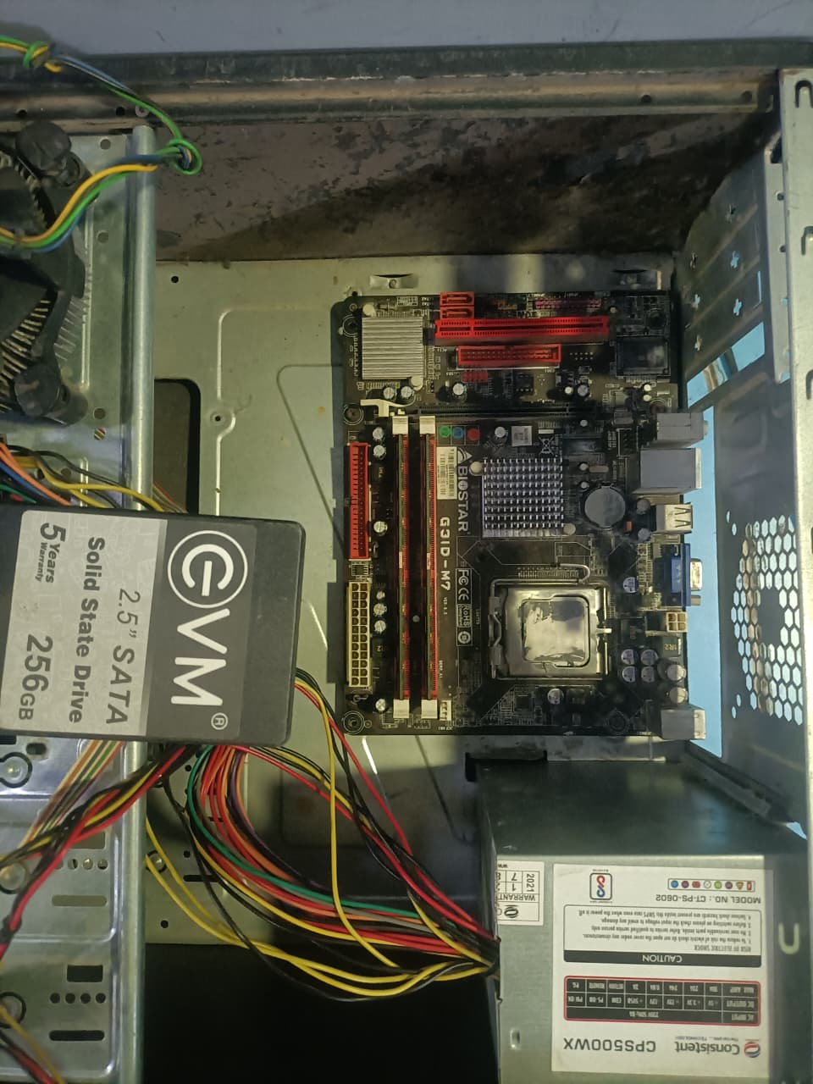
- Step 3: Disconnect Internal Power, Data Cables & Remove CPU Cooler: Unplug the 24-pin motherboard cable, 8-pin CPU power cable, GPU power leads, front-panel wires, and SATA data/power lines. Unplug the CPU fan header, unscrew the cooler bracket, gently twist and lift off the heatsink.

- Step 4: Remove the RAM Sticks & Remove Storage Drives: Push down the retention clips on either side of the RAM slots until the sticks pop up, then lift them out. Unscrew and remove SATA SSDs from drive cages.

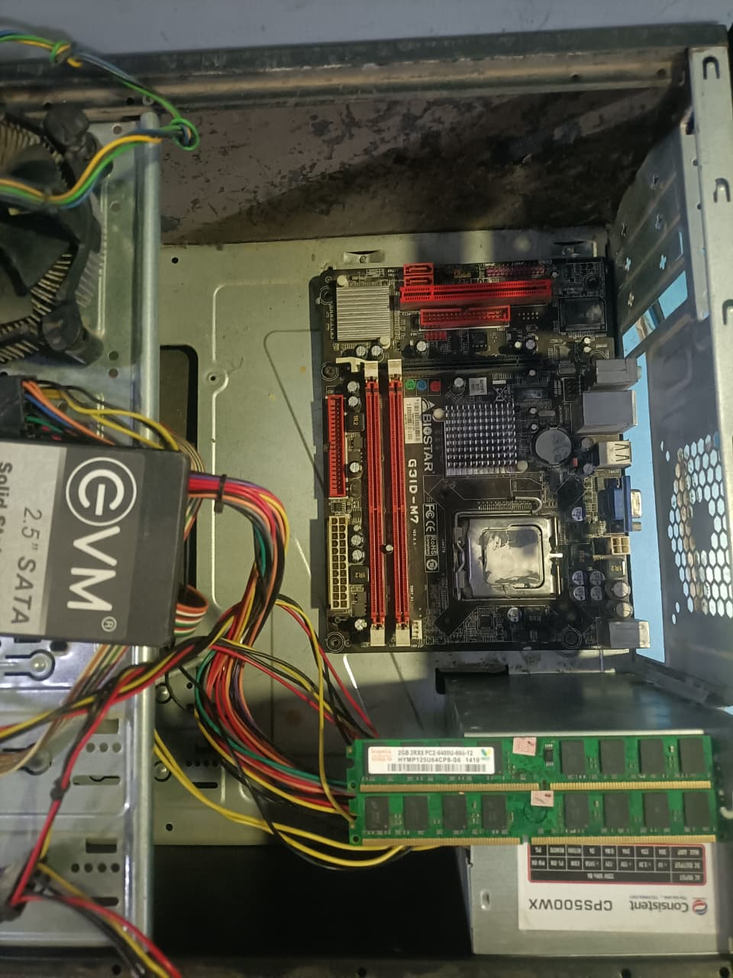

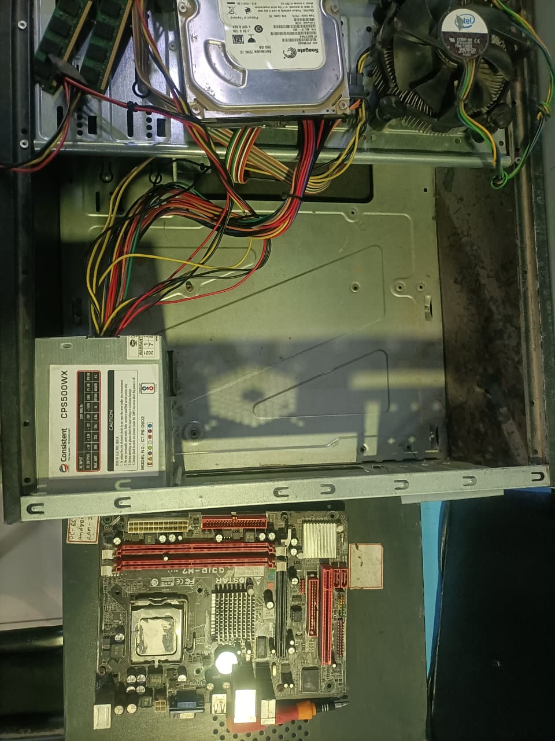
- Step 5: Remove Motherboard & Power Supply: Unscrew all motherboard mounting screws to remove the board, then remove the 4 rear screws holding the PSU to slide it out.
Task 3: Step-by-Step PC Reassembly Guide & Order of Assembly

- Step 1: Pre-Install CPU, RAM, and SSD on Motherboard (Outside Case): Installing these on the desk.
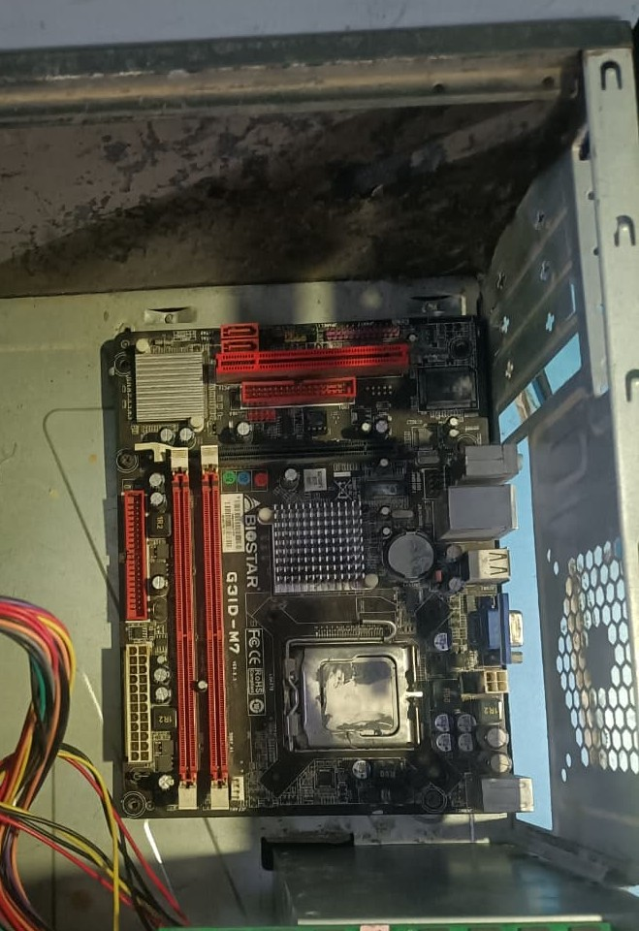
- Step 2: Install the Power Supply (PSU) & Mount Motherboard into Case: Screw the PSU into the bottom/top of the case first and feed the cables. Align the board with the rear I/O shield and secure it onto the case

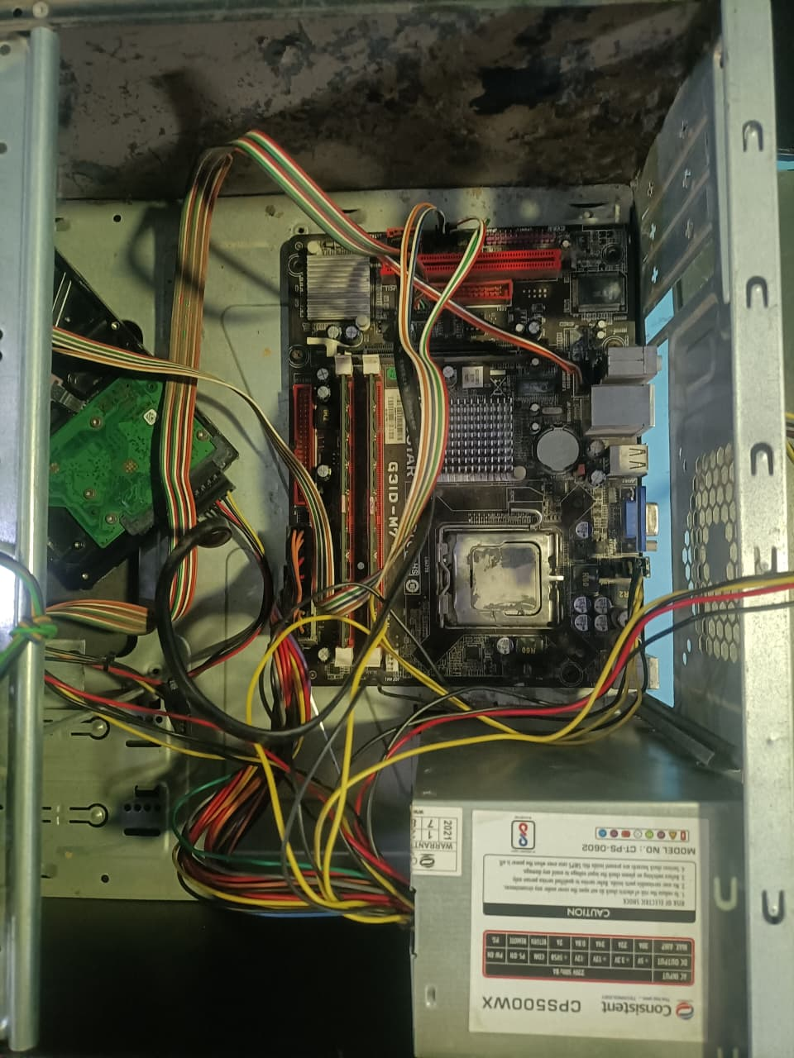
- Step 3: Route and Connect Main Power, Front-Panel Cables & Storage Drives: Plug in the 24-pin ATX, 8-pin CPU power, power switch headers, front USB, and audio connectors. Secure hard drives into drive bays and connect SATA data cables to the motherboard.

- Step 4: Install CPU Cooler, Connect CPU Fan, & Case Fans: Mount the heatsink securely over thermal paste and plug the fan wire into the CPU_FAN header.
- Step 5: Close Case & Test Boot: Replace side panels, connect the power cord and monitor, and power on to confirm entry into the BIOS/UEFI screen.

Task 4: Safety Precautions & Tools Checklist

Required Tools
- Phillips Head Screwdriver : Standard size needed for nearly all case, motherboard, and power supply screws.
- Magnetic Parts Tray / Small Cups: Prevents small screws and standoffs from rolling away or falling onto circuit boards.
- Cable Ties / Velcro Straps: Keeps wiring clean and away from spinning fan blades.
Safety Precautions
- Drain Residual Electricity: Always unplug the PC and hold down the front power button for 5 seconds to drain remaining charge from power supply capacitors before touching parts.
- Prevent Electrostatic Discharge (ESD): Wear an anti-static wrist strap or touch an unpainted metal surface regularly to prevent static shocks from damaging delicate silicon chips.
- Never Force Connections: RAM, CPU pins, and power plugs only fit in one orientation; forcing them can permanently bend pins or snap motherboard sockets.
- Work on a Clear, Hard Surface: Avoid working on carpets or rugs, which generate static electricity and make finding dropped screws difficult.

